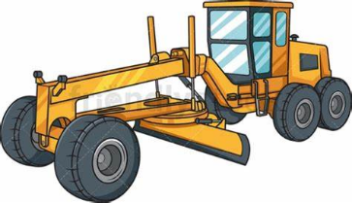**The Rural Municipality of**

**Hazel Dell No.335**

**Newsletter 2022**

**ELECTIONS**

This year Divisions 2, 4 & 6 are up for nominations. Forms will be made available at the RM office for anyone who is interested in running for council.

If necessary, elections will be held November 9, 2022 at the Okla Community Hall.

**Please check local posters for updates this fall.**

**DUST CONTROL**

Once each spring the RM orders in Calcium Chloride flakes for dust control and is available for pick up for our ratepayers **at our cost**: first come - first served as supply is limited. To ensure you get the amount you need please call the office ahead of time (March or earlier) and your specific amount will be ordered and set aside for you.

The RM does not apply the calcium but does need to prep the road ahead of installation. If you get your dust control from another source, please let us know before applying it.

It is up to you to find someone to apply it.

**APAS BENEFITS**

The RM of Hazel Dell has paid a membership fee to the Agricultural Producers Association of Saskatchewan (APAS). This membership provides all those who receive a tax notice from this RM with discounts and/ or special pricing by presenting the APAS card to: Mark’s, The Co-Operators (Insurance), Grainger Canada, and Chrysler/Dodge, just to name a few. For more information including a full list of rewards please visit [www.APAS.ca/my-rewards](http://www.APAS.ca/my-rewards). The discount card is valid until August of 2023 and can be used multiple times.

**RECYCLE BINS**

Parkland Regional Waste Management Authority would like to remind everyone:

1. All cardboard or paper products in recycle bins **must be clean**. Anything contaminated with chemicals, oil, or foods (ie: pizza boxes) cannot be recycled.
2. **PLEASE FLATTEN BOXES** to save space.
3. Plastics must be separated and put in clear plastic bags for easy separation at the plant.
4. Recycle bins are blue and kept at a separate location from household garbage bins.

**Please don’t put household garbage in the recycle bins!!** Not only is it very time consuming to separate items at the recycling plant, but household garbage can contaminate clean recyclable products, defeating the purpose of the bins.

***Thank you for your attention.***

**2022 CUSTOM WORK RATES**

Please plan ahead and allow more than one days’ notice for any custom work as we cannot guarantee when the equipment can get to your area.

Grader = blading or plowing: $20 min charge (up to 15 min); $200/hr reg rate (applied after 15 min)

If a special trip is requested, the regular rate will apply from the time the grader leaves the RM shop.

Tractor & mower = $200/hr

Please note: as per Sask government requirements, PST must be charged for any permanent ground movement (ie: blading), but NOT to maintenance such as snowplowing or grass mowing.

**HAYING DITCHES**

Just a reminder to those who wish to cut the ditches for hay: Please call the office every spring with the locations you wish for our mower to skip over. Bales must be removed from the ditches as soon as possible.

**ROAD SIGNS & FARM CIVIC ADDRESSES**

The RM is still working on signing virtually all intersections in the RM **for the purpose of emergency vehicles and services (911)**. In this process, there are civic addresses available for farm yards.

If there is a civic address assigned to your location, it should show up on your tax notice for that property.

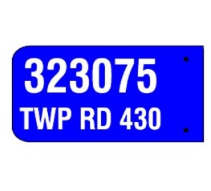Please call the office if you would like to order a standard (blue) address sign for your driveway.

Please note that this registry **DOES NOT** include any other services such as Google Maps or Purolator/home delivery services.

**ONLINE PAYMENTS**

The RM is accepting e-transfers for payments on taxes or custom work. All you need is our email address: [rm335@sasktel.net](mailto:rm335@sasktel.net) . We ask that you use the memo field to specify what the payment is for,

ie: name, custom invoice number, or owner number (found on the top right corner of your tax notice), or specific land locations. We are set up with direct deposit so we will not have to answer any security question you set up.

We are also set up with the Credit Union to accept payment for taxes via online bill payments. Our registered vendor name is: **Hazel Dell No. 335 (RM)** The account number you need for setting up is your specific owner number, which is a 4-digit number at the top right corner of your tax notice. If the number is less than 4 digits you must add a zero (0) in FRONT of the number. For example, if your owner number is 5, you would use 0005. If you have more than one notice, you will have a separate owner number for each, and will need to make separate payments for each.

Receipts will be mailed once payment is processed.