FORM A Application # _______________
Zoning Bylaw No. 7-2023 Roll # _______________
Location: _______________

RM OF HAZEL DELL No. 335
DEVELOPMENT PERMIT APPLICATION

Development Permit Applications may take approximately 1-2 months to process due to the requirement of additional information, notification procedures, presentation to Council, or due to the time of year. For more information about permit requirements, contact the office at (306) 325-4315.

Application Fees:

1. Permitted Use - $25
2. Discretionary Use - $50

Contact the office to determine if your application is a permitted or discretionary use. Permitted and discretionary application fees are subject to additional fees if further investigation is required. Permit fee rationale is available upon request.

Site and Floor Plan Requirements:

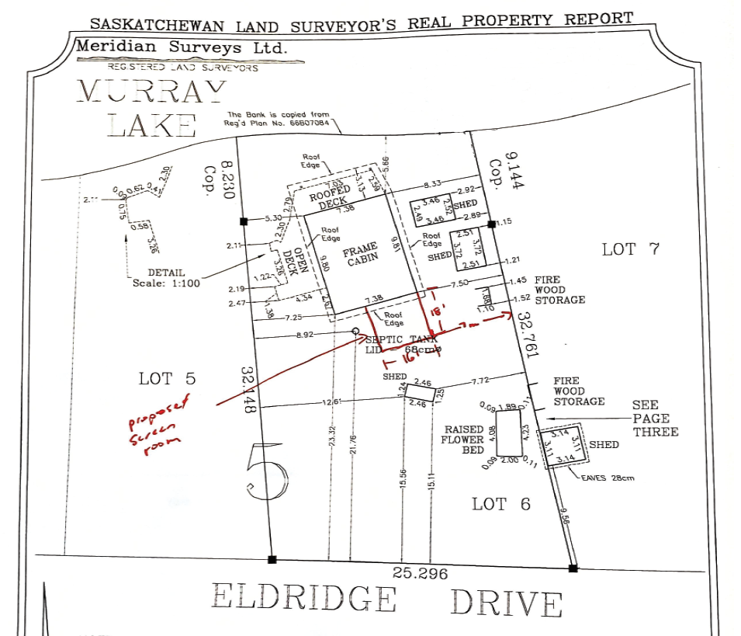
Your permit shall not be considered completed until you submit all of the following:
- Submission of any required photos, floor plans or exterior elevations of the building;
- Attach a site plan drawing clearly showing the location of the survey pins and parcel boundary measurements. The following shall include the following:
- North arrow
- Label, and provide location and dimensions of all existing buildings and structures and all distances
- Label, and provide location of all proposed buildings and structures and all distances
- Location of water and sewer utility system, with distances to property boundary
- Location of all existing and proposed approaches and driveways.
- Location of adjacent roadway.
- Location of distinguishing physical features located on or adjacent to the property including, such as things as, sloughs, streams, drainage ways including culverts, wetlands, slopes, bluffs, etc.
- Floor plan for residential buildings (i.e, cabins, bunkhouses).
- Cross-section diagram of decks; and
- Location of on-site parking.
Development Information:

1. Applicant:

Name: ____________________________________ Phone: _________________

Address: __________________________________ Postal code: _____________
Email: ____________________________________
____
2. Registered Owner: ____ as above or,

Name: ____________________________________ Phone: _________________

Address: __________________________________ Postal code: _____________

3. Legal Land Description:

LSD or 1/4 ______ Sec. ______ Twp. ______ Rge. ______ W ___

Lot(s) ______ Block ______ Registered Plan No. ______________ Hamlet __________

4. Existing use of land, buildings, and structures:
________________________________________________________________________

________________________________________________________________________

5. Proposed use of land, buildings and structures:
________________________________________________________________________

________________________________________________________________________

6. Proposed development involves: Residential Use:
New building ____ Addition ____ Principal ____
Move in building* ____ Alteration ____ Secondary ____
Modular home* ____ Mobile home* ____

*NOTE: Move in buildings, modular and mobile homes require photos of each side of building in its current condition.

Age of building: __________

7. Estimated dates of development:
Commencement: __________ Completion: __________

8. Other information (e.g. proposed sewage system) _________________________________

9. Declaration of Applicant:

I/We further agree to comply with all Bylaws & Regulations of the RM of Hazel Dell No. 335 respecting development and I/we acknowledge that it is my/our responsibility to ensure compliance with all Saskatchewan Regulations and Acts including The Construction Codes Act, regardless of any review or inspection that may or may not occur by any official of the Municipality. In the event that I/we, the Land Owner(s), fail to complete the Real Property Surveyors Report (RPSR), as required, I/we agree that the RM may complete the RPSR at my/our expense and invoice me/us for the cost along with any necessary administration fees. I/We agree that any expense incurred by the RM to obtain a RPSR and administration or application fees not paid may be added by the RM to the property tax roll of the Land and is deemed for all purposes to be a tax on the Land from the date it was added to the tax roll and forms a lien against the Land in favour of the RM from the date it was added to the tax roll.

I/We acknowledge that my/our personal information (name, phone number, home address and postal code) are being collected under the authority of section 25 of The Freedom of Information and Protection of Privacy Act, and further, that this information will be used internally within the RM office and will be retained with my/our land file information. If you have questions or concerns about this collection of information, please contact the Office of the Saskatchewan Information and Privacy Commissioner at Toll Free 1-877-748-2298 (306-787-8350) or at webmaster@oipc.sk.ca .

I/We also agree that any construction causing damage to Municipal infrastructure shall be fixed at my/our cost. Furthermore, should I/we be bringing in a Ready-to-Move (RTM) or Move-In (MI) building that I/we shall be responsible for all costs associated with tree or brush removal required within municipal right-of-way to accommodate the building being moved along a municipal road allowance.

Where applicable, if a permit is issued for a temporary development on dedicated lands, I/We agree that this does not give I/We an exclusive right of use of the dedicated lands or its development.

I/We hereby acknowledge that in signing this application that I/We am responsible to determine the presence, and comply with any requirement of, any: public or private utility or service connection, whether or not protected by easement; easement for drainage works; surface lease; development standards; agreement; or other instrument registered to title.

I/We understand that development permits expire within 12 months of issuance unless an extension is granted. I/We understand that any permit approval conditions must be completed within 24 months or the permit is invalid.

I/We, ____________________________ and, ____________________________ solemnly declare that all the above statements contained within this application are true, and I/we make this solemn declaration conscientiously believing it to be true, and knowing that it is of the same force and effect as if made under oath, and by virtue of the “Canada Evidence Act”.

I/We have reviewed land title registry information for all relevant interests and easements on the land subject to this permit application, and I/We hereby declare that all information as proposed in this permit is in alignment with all title interest registrations. I/We also agree that I/we am responsible to ensure that any and all development is completed in alignment with all interests registered within the land titles registry.

_______________ __________________________ _______________ ________________________
Date Signature Date Signature

HAMLET BOARD USE ONLY:

Hamlet of ________________________ Date: ______________________
____
1. ____ APPROVED Confirmed through: Email
____
2. ____ REFUSED

Board Comments: ______________________________________________________________

COUNCILLOR – PERMITTED USE ONLY: **NOTE: discretionary uses must have a resolution from Council**

Division ________________________ Date: ______________________
____
1. ____ APPROVED Confirmed through: Email

Board Comments: ______________________________________________________________

